Statement of Purpose

Orbis Support are a supported living organisation who provide bespoke, person centred support to vulnerable adults and young people with learning disabilities, autism and complex needs who wish live in their homes in the community

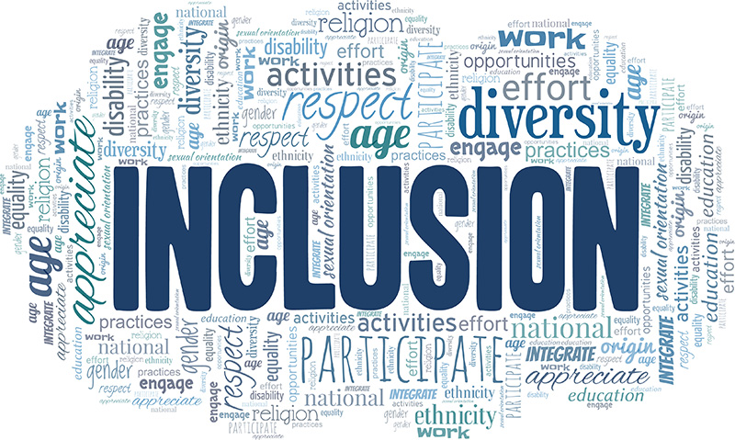

___________________________________________________

This Statement of Purpose can be provided in large print, audio, or in an alternative language upon request

Orbis Support is a company that specialise in providing valued based support that is person centred to promote inclusion for vulnerable adults with autism, learning disabilities and complex needs.

Bespoke - Supported Living

- To provide tailored 24-hour support to adults with learning disabilities, autism and complex needs with behaviours that may challenge.

- We understand that every person is unique, and tailor every service to meet the needs and aspirations of the person being supported.

- Work hand in hand with the person being supported, their families and professionals to create and deliver bespoke, person-centred support plans.

- Offer support in a way that enables each person to live the life they wish to live, within their own home within their local community.

- We employee staff who have a variety of experiences and skills and we train our workforce to a high standard to enable them to deliver support that promotes the needs of the individual they are employed to support.

- Orbis is committed to support every person to have a stimulating, fulfilling life and be able to contribute to their local community.

Person Centred – Supported Living

We understand the importance of the person choosing the location they want to live, the house they want to become their home, to ensure it meets their needs and aspirations. It is important that they feel safe and secure and have a voice when choosing their new home.

- They chose where they want to live.

- They chose how they want their home to look.

- They choose the community they want to be part of.

We believe that every person has their own abilities, and strengths and everyone has a unique contribution to make.

- We understand the importance of having the right environment. Orbis limit the use of files and use technology rather than paper, with a system called ‘Nourish’ so their home looks like a home and not a working environment for the support staff.

- Our on-line system has a family portal access so relatives and loved ones can see daily updates with photos of what activities they have been doing, places they have been and how they are doing so families feel included.

Progression and the Future

- We are dedicated to developing our workforce and continue to source new up to date training to give our support staff the best skills and knowledge available so they can deliver the best possible support Orbis believes everyone has a right to.

- We listen to what families, professionals, and the people we support have to say and always look at new ways of making sure we can work together to promote good quality, person-centred and inclusive service.

How will we do this

- We will create a support plan that clearly outlines what support will be delivered and how it will be delivered, no two support plans are the same as no two people are the same, each support plan is tailored to meet the needs of each person.

- We promote and welcome the participation of those involved in each person to have their input, to promote inclusion and openness.

- Engage people supported by Orbis, in the ongoing development and quality reviews of Orbis.

- Work with all people within a framework of Equal Opportunity, and non-discriminatory practice.

- By always keeping people safe.

- By being a mindful, fair, and responsible employer.

- Value everyone’s contributions, opinions, and views.

- Be always honest and open.

- Develop a workforce who are appropriately recruited, highly trained and well managed to ensure they provide support which is always of the highest standard.

